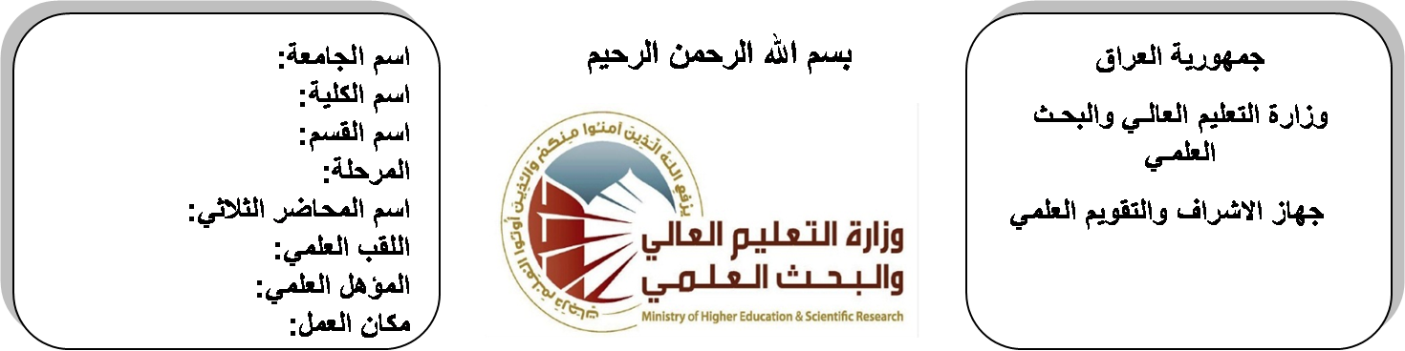

**Republic of Iraq**

**Ministry of Higher Education**

**& Scientific Research**

**University: Diyala University**

**College: College of Engineering**

**Department: Electronic Engineering**

**Stage:third**

**Lecturer name:** Isam Salah Hameed Khamees

**Qualification: M.Sc**

**Place of work: Electronic Dept.**

**(( Annual teaching plan form))**

|  |  |  |  |  |
| --- | --- | --- | --- | --- |
| **Lecturer Name** | **Isam Salah Hameed Khamees** | | | |
| **Email** | [**husamtakt@yahoo.com**](mailto:husamtakt@yahoo.com) | | | |
| **Subject** | Digital Signal Processing (DSP) | | | |
| **Aims** | **The aim of this subject is to cover the novel techniques of digital signal and its processing that is involved in different applications including electronic and communication engineering. Besides, the topic of DSP covers the diverse signals such as that of human body and puts them under control by using mathematical algorithms in order to make the students ready to understand and comprehend the scientific theories and their applications related to their field of the study.** | | | |
| **Textbooks** | 1. **Digital Signal Processing: principles, algorithms, and applications, third edition, by John G. Proakis and Dimitris G. Manolakis.** 2. **Digital Signal Processing, fundamentals and applications, 2008, by Li Tan.** | | | |
| **Additional Textbooks** | 1. **Mathematics for Engineers and Applied Scientists, 2nd edition, by Stanley.** 2. **Introductory Digital Signal Processing, 2nd edition by P. A. Lynn.** | | | |
| **Assessments** | **First Semester** | **Second Semester** | **Laboratory** | **Final Exam** |
| 20% | 20% |  | 60% |
| **Notes** |  | | | |

**Schedule Weekly Lessons - First Semester**

|  |  |  |  |  |
| --- | --- | --- | --- | --- |
| **Week** | **Date** | **Lectures** | **Lab. Experments** | **Notes** |
| 1 | **29/9/** | Introduction to DSP |  |  |
| 2 | **5/10/** | The concept of frequency in continues time and discrete time signals |  |  |
| 3 | **12/10/** | Digital signals and systems |  |  |
| 4 | **19/10/** | Discrete time Systems |  |  |
| 5 | **26/10/** | Block diagram representation of discrete time systems |  |  |
| 6 | **2/11/** | Discrete time systems as difference equation |  |  |
| 7 | **9/11/** | Sampling theory amd Nyquist rate |  |  |
| 8 | **16/11/** | Linear convolution and signal comparison |  |  |
| 9 | **23/11/** | Circular convolution of discrete time sequence |  |  |
| 10 | **30/11/** | Discrete Fourier Transform DFT |  |  |
| 11 | **7/12/** | Inverse of Discrete Fourier Transform DFT |  |  |
| 12 | **14/12/** | Application of Discrete Fourier Transform |  |  |
| 13 | **21/12/** | Fast Fourier Transform FFT |  |  |
| 14 | **28/12/** | The Inverse of Fast Fourier Transform FFT |  |  |
| 15 | **4/1/** | Applications of Discrete Fourier Transform |  |  |
| 16 | **11/1/** | Seminars |  |  |
| Half Year holiday | 15/1/ to  1/2/ |  |  |  |

**Lecturer Signature Head of Dept. Signature Dean Signature**

**Schedule Weekly Lessons - Second Semester**

|  |  |  |  |  |
| --- | --- | --- | --- | --- |
| **Week** | **Date** | **Lectures** | **Lab. Experments** | **Notes** |
| 1 | **15/2/** | Discrete time system analysis using Z-transform |  |  |
| 2 | **22/2/** | Discrete time system analysis using Z-transform |  |  |
| 3 | **1/3/** | Discrete time system analysis using  Z-transform |  |  |
| 4 | **8/3/** | Inverse Z-transform |  |  |
| 5 | **15/3/** | Digital Filters |  |  |
| 6 | **22/3/** | Realization of digital filters |  |  |
| 7 | **29/3/** | Analog Filter design |  |  |
| 8 | **5/4/** | Butterworth filter design  (LPF, HPF, BPF, and BSF( |  |  |
| 9 | **12/4/** | Chebyshev filter design  (LPF, HPF, BPF, and BSF( |  |  |
| 10 | **19/4/** | FIR Digital Filter Design |  |  |
| 11 | **26/4/** | IIR Digital Filter Design |  |  |
| 12 | **3/5/** | Bilinear Transformation Design Method |  |  |
| 13 | **10/5/** | Design of FIR filters using windows |  |  |
| 14 | **17/5/** | Application of digital filters |  |  |
| 15 | **24/5/** | Introduction to adaptive filtering  And its application |  |  |
| 16 | **1/6/** | Seminars |  |  |

**Lecturer Signature Head of Dept. Signature Dean Signature**